A.Ramesh Babu K.V.Acharya
Joint Convener Joint Convener,
Flat No 1103, Block 3B, J-208 Vijay Rattan Vihar,
S.M.R. Vinay Fountainhead, Sector 15, Part II,
Culvary Temple Road, Gurgaon 122001
Hyderabad 500 049 Mobile: 09868220338
Mobile: 09849381995 E-mail: acharyavedavyasa46@gmail.com
E-mail: babu2609@gmail.com
__________________________________________________________________________________
Dated: 30.11.2016
To
The Chief Executive Officer,
Indian Banks’ Association,
World Trade Centre 6th Floor,
Centre 1 Building,
World Trade Centre Complex,
Cuff Parade, Mumbai 400005

Respected Sir,
Sub: Long Pending Issues of Bank Pensioners and Retirees
We understand that the Managing Committee of IBA in its meeting held on 29.7.2016 to consider the issues pertaining to Retirees resolved that in the absence of specific mandate from Member Banks to IBA to discuss the issues on their behalf be treated as withdrawn. The absence of mandate from the Member Banks to discuss these issues was cited as reason for not taking any further action on those issues.
In this connection we would like to invite your kind attention to Charter of Demands submitted to IBA by the organisations of serving officers and employees in October 2012 contain a separate chapter on Superannuation Benefits including Pension. You will appreciate that IBA had then forwarded a copy of the said Charter of Demands to all the Member Banks and sought requisite mandate to discuss the Charter of Demands. Accordingly all the Member Banks had given mandate to IBA authorising it to discuss Charter of Demands including Superannuation Benefits. Under such circumstances the reason given by IBA for not taking any further action is unfounded and factually incorrect. We request you to examine the issue in right perspective.
It is also pertinent to mention that the Pension issues of Bank Employees and Officers are governed by Bank Employees Pension Regulations 1995. A perusal of Pension Regulations would reveal that there is no provision to secure mandate from Bank Managements as a pre condition to consider any improvement. Even on this count, the ground for not taking any further action by IBA is violative of Pension Regulations.
The very fact that IBA had signed a Record Note at the time of signing Xth Bipartite/Joint Note on 25.05.2015 on all the pending issues of Retirees including improvement in Family Pension, 100% DA neutralisation to pre 2002 Retirees and updation of Pension etc stands a mute testimony to the legitimate demands of Retirees in this regard. The said record note need to be respected by IBA by settling the issues contained therein at the earliest. The very fact that IBA has collected from Member Banks the data relating to (i) 100% DA for pre 2002 Retirees (ii) Improvement in Family Pension (iii) Pension Updation and (iv) One more Pension option to leftover Retirees/Resignees vindicates the desirability of a positive consideration of our demands.
It is also reiterated that at the time of signing of Record Note IBA has given a solemn assurance about resolving the issues amicably. It is disheartening that despite such a commitment, IBA has been changing its stance to avoid a meaningful discussion to resolve the issues giving lame excuses irrelevantly. We have been repeatedly requesting you to hold negotiations with the Coordination of Bank Pensioners’ and Retirees Organisations (CBPRO) which comprehensively represent the Bank Pensioners and Retirees. We once again request you to honour the commitment by initiating meaningful discussion for resolving the issues relating to Bank Pensioners and Retirees.
As regards the contention of IBA that Pension Scheme of Banks is a Funded Scheme and additional liability if any towards pension is to be allocated from the profits of the Banks is misleading. We wish to invite to your kind attention to Pension Regulation 5(3) which provides that the Banks shall be a contributor to the fund and shall ensure that the sufficient sums are placed in it to enable the trustees to make due payments to beneficiaries under these Regulations. Regulation 11 further provides that Bank shall cause an investigation to be made by an actuary into the financial condition of the fund every financial year on the 31st day of March and make such additional contributions to the fund as may be required to secure payment of the benefits under these Regulations. It is thus clear that the Pension Regulations do not provide for allocation of additional funds from the profits of the Banks. Hence inadequacy or otherwise of profit cannot be cited as a ground for declining the legitimate demands of Bank Pensioners and Retirees. Various Judicial pronouncements including by Hon’ble Supreme Court also substantiate our contentions. It is reiterated that the Pension is considered as deferred wages and hence the Bank Pension Scheme being a DEFINED BENEFIT PENSION SCHEME cannot by any stretch of imagination be sought to be distorted by the Managing Committee of IBA.
It is also clarified that the contributions to the Pension Funds are covered under Pension Regulations which are subordinate legislations and hence it is mandatory on the part of Banks to adequately provide for Pension Fund. It is a paradox that the Regulatory Provisions dictated by RBI for Non Performing Assets (NPA) are made by the Banks without any application of mind irrespective of profitability of the Banks. It is submitted that Regulatory Provisions of RBI cannot be treated superior to Legislative Provisions. You are therefore requested to consider the issues relating to Bank Pensioners and Retirees holistically in this perspective.
We once again reiterated that the Pension Regulation 35(1) provides that Basic Pension and additional Pension, wherever applicable shall be updated. You will appreciate that this provision providing for Pension updation was implemented in true spirit at the time of introduction of Pension Scheme in the Banks by effecting updation in respect of those employees who superannuated between 1.1.1986 and 31.10.1987. The present demand is relating to updation of Basic Pension and hence is to restore the practice of updation.
In view of the foregoing facts we request you to hold talks with us on all the pending issues concerning the Bank Pensioners and Retirees and resolve the same immediately.
Thanking you,
Yours Sincerely,
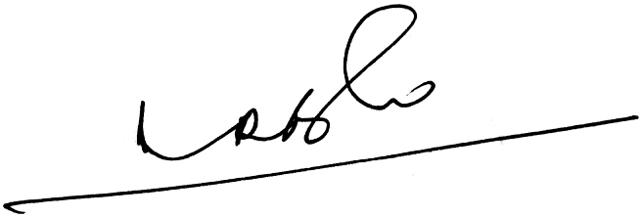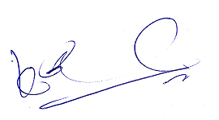
A.Ramesh Babu K.V.Acharya
Joint Conveners

