A.Ramesh Babu K.V.Acharya
Joint Convener Joint Convener,
Flat No 1103, Block 3B, J-208 Vijay Rattan Vihar,
S.M.R. Vinay Fountainhead, Sector 15, Part II,
Culvary Temple Road, Gurgaon 122001
Hyderabad 500 049 Mobile: 09868220338
Mobile: 09849381995 E-mail: acharyavedavyasa46@gmail.com
E-mail: babu2609@gmail.com
_________________________________________________________________________________________
Dated: 15.02.2017
Shri V G Kannan
The Chief Executive,
Indian Banks’ Association
Mumbai.

Respected Sir,

Sub: MEMORANDUM BY CBPRO DELEGATION REGARDING BANK PENSIONERS ISSUES.

We are extremely thankful to your Good-self for giving an audience to the delegation of CBPRO who have come to Mumbai to submit the Memorandum and also to explain to your Good-self the anguish and anxiety of Bank Pensioners concerning their issues which have remained unresolved even after several representations to Indian Banks’ Association. It is with great hope and expectations that we wish to once again place before you the following main issues which need your kind attention and consideration:

- 100% DA RELIEF TO PRE-NOVEMBER 2002 RETIREES. It is a fact that extension of the new formula of 100% DA from 2005 had not been denied to the pre-2002 Retirees in the settlement concluded between the Unions, Associations and the IBA, but the same was arbitrarily denied to pre-2002 Retirees. Earlier the IBA was pointing out about the appeals pending in the Hon’ble Supreme Court as the reason not being able to consider the issue favourably on the ground that the matter was sub-judice. Same was also pointed out in the Record Note in the 10th Bipartite Settlement. Now since there is no such situation prevailing and also since 100% DA neutralisation is given to all Retired Government Employees, RBI Employees and such other Public Sector Undertakings where the Pension Scheme is in existence, denying the same to pre-2002 Retirees who are very old veterans of the Banking Industry is discriminatory. We now expect IBA to take a fair and just view on this issue and provide relief to pre-2002 Retirees.

- IMPROVEMENT IN FAMILY PENSION. This is again an issue which should be viewed on a humanitarian ground as the Family Pensioners are mostly wives of the deceased employees. With the ceiling on the Family Pension the amount comes to maximum about Rs. 14000.00 with DA even to the spouses of deceased Senior Executives and as low as Rs. 4000.00 in the case of deceased junior level Employee. In respect of deceased Retired Government Employees and RBI the Family Pension has already been improved from 15% to 30%. To enable the spouses of deceased employees to live the evening of their life with dignity it is very urgently required to improve their Family Pension from 15% to 30% without ceiling.

- PENSION UPDATION. The Bank Employees Pension Regulations very clearly provide for updation of Basic Pension and additional Pension whenever the revision in pay takes place for the Serving Employees. The Bank Pension Scheme as per the Pension settlement is modelled on the lines of Pension Scheme existing in Government and RBI. The non-updation of Pension has resulted in vide disparity of Basic Pension between those Retired years back and those Retiring now. It has become difficult for the past retirees to meet the rise in cost of essentials, as the DA rise does not compensate fully to lead a fair living. As a mark of fair governance this should be immediately removed and regular updation of pension should be provided to all Retirees in the Banking Industry.

- MEDICAL INSURANCE SCHEME. Health problem is one of the most serious issues the Retirees encounter in their old age. It is naturally expected that the Employer will continue to take care of the Medical needs of their past employees as available to the Retired Government Employees. But unfortunately the minimum expectations of the Bank Retirees not only side lined but also got aggravated because of the steep threefold increase in the Medical Insurance Premium for the current year. There is no proper method of reimbursement of the insurance premium in the Banking industry so far as the Retirees are concerned. Even the Department of Financial Services, Government of India when they communicated to the IBA in the year 2012 to devise Medical Insurance Scheme to both Serving Employees and Retired Employees did not suggest that the premium amount should be borne by the Retired Employees. Going by the spirit of the Government communication it is very clear that the payment of premium should be met by the Banks in respect of both Serving and Retired Employees. Hence it is requested that the Government communication in this regard is implemented in letter and spirit in respect of Retired Employees also.

Sir, the Bank Retirees are having numerous grievances in addition to the above. So we earnestly request you to have a system of consultation with the Retiree’s Organisations from time to time and give the Bank Retirees the comfort of living their left over period of life with peace and dignity, recognising their meritorious services to the Banking Industry and the Nation.

Thanking you,

Yours sincerely,
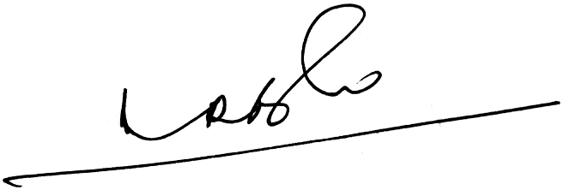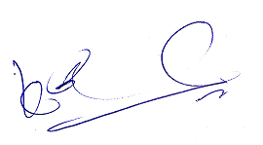
(A.Ramesh Babu) (K.V.Acharya)
Joint Conveners CBPRO

