**A.Ramesh Babu K.V.Acharya**

**Joint Convener Joint Convener,**

**Flat No 1103, Block 3B, J-208 Vijay Rattan Vihar,**

**S.M.R. Vinay Fountainhead, Sector 15, Part II,**

**Culvary Temple Road, Gurgaon 122001**

**Hyderabad 500 049 Mobile: 09868220338**

**Mobile: 09849381995 E-mail: acharyavedavyasa46@gmail.com**

**E-mail:** [**babu2609@gmail.com**](mailto:babu2609@gmail.com)

**_________________________________________________________________________**

**CBPRO Circular No: 005/2018 Dated: 14.02.2018**

Dear Comrades,

## RE: Supreme Court Judgement regarding anomaly in settlement

## Re-fixation of Basic Pension and payment of arrears for those retired between April 1998 and October 2002.

We are glad to advise  that the various petitions filed by our Retiree Comrades challenging the settlement which deprived those who Retired between 1998 and 31st October, 2002 full pension  @  50% of their last drawn Basic Pay, the Hon'ble Supreme Court in its judgement pronounced  by  Hon’ble  Justice Mr. Arun Mishra and Hon’ble Justice Mr. Amitava Roy on 13th Feb 2018 restored the same as per Pension Regulations and ordered payment of arrears for those who retired during the above period with interest at 9%.

For the benefit of our members we wish to state that in the wage settlement of 1998 the merger point of DA was irrationally fixed at 1616 points for the purpose of fixing the Basic Pension to the Retirees of the relevant period whereas for the serving employees and Officers it was fixed at 1684 points. This reduced the Basic Pension to about 41% of the last drawn Basic Pay instead of 50% of the last drawn Basic Pay as per the Bank Employees Pension Regulation 1995.

Retired Petitioners from Bank of Baroda and other banks challenged the above provision of the wage settlement arguing that this would amount to violation of Bank Employees Pension Regulation 1995. The Hon’ble Supreme Court was pleased to issue order in favour of Retiree Petitioners.  This is one more instance of display of irrationality and illegality by the IBA through a wage settlement which is again now **SET A SIDE** by the Hon'ble Supreme Court.

We congratulate RBONC and Bank of Baroda Retired Officers Association who are the constituents of CBPRO & the Retiree comrades of other Banks of the relevant period for getting justice from the Hon'ble Supreme Court.

AT THE SAME TIME WE WISH TO POINT OUT TO OUR RETIREE COMRADES THAT THE JUDGEMENT REGARDING 100% DA NEUTRALIZATION IS STILL PENDING IN THE SUPREME COURT FOR PRONOUNCING THE RESERVED JUDGEMENT. WE WISH AND HOPE THAT THE JUDGEMENT WILL BE DELIVERED IN REGARD TO 100% DA NEUTRALIZATION VERY SOON.

Regards,

Yours Comradely,

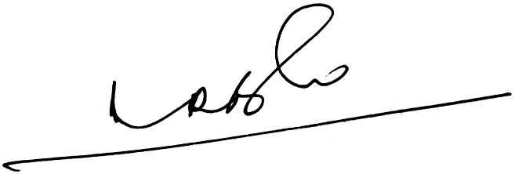 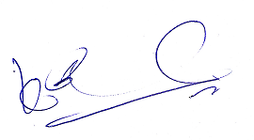

**A.Ramesh Babu K.V.Acharya**

**Joint Conveners**