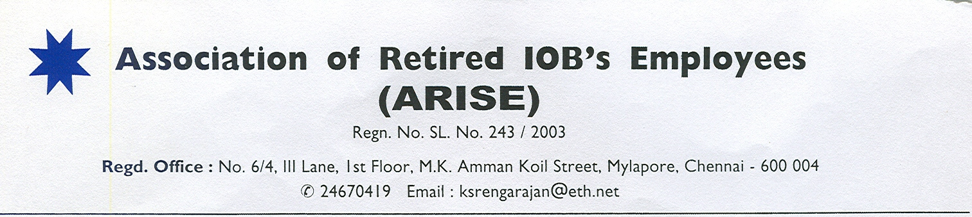 To 19/02/2018
The Managing Director & CEO, Indian Overseas Bank, Central Office, Chennai
Dear Sir,
Sub: Resolution of pending issues
We never wanted to interrupt you as we are aware that every public sector bank facing a crisis never before requires the unswerving attention of its CEO. The drain on the bottom line caused by the present crisis cannot however be mitigated a wee bit by the saving on withholding benefits to retirees as the cost of these benefits is a pittance compared to the losses the banks are posting. Realizing that it is not fair and wise to hold to ransom the benefits of retirees, most banks are resolving bank-level issues concerning the retirees.
While every other bank, in spite of similar or more problems like our bank, is conceding to meet the basic needs of retirees, we have been receiving a stony silence to all our letters of requests. We are disappointed and never thought that our contribution to the bank would fail to be recognized by the bank even when it retains its identity. Our needs costing a pittance make practically no difference to the bank’s bottom line. Is this attitude of the bank better than a son starving his parents to improve his savings?
While every past CEO gave us some relief and never hesitated to give us audience which we never sought often, the situation became different with your immediate predecessor Mr.Koteeswaran taking charge of the bank. He robbed an existing benefit, the ½% extra interest to senior citizen retirees of our bank. 1/2% extra interest is our legal and moral right and every other bank has conceded this right. We fervently hoped this ill-treatment of the retirees would become a thing of the past, more so when you spontaneously announced a relief of Rs.2000 in 2016 to meet partly the cost of the New Medical Insurance Premium pending resolution of the issue of Bank’s contribution under REMAS. Our hopes were belied when nothing came and a year rolled by when the next year’s (year-2017’s) premium became due. This time, even the Rs.2000 relief did not come through. The steep increase in premium with no relief from the bank made many family pensioners and pensioners with meagre pension opt out leaving their health and welfare to the cruel hands of fate.
When the contractual benefit under REMAS for New Medical Insurance was withheld, we sincerely believed that you had urgent things on hand that were critical to the survival of the bank and you required time to take a decision. Our requests in person resting with our last letter of 6/10/2017 was not even responded, leave alone being considered favourably. Adding to our woes is the present HR Head who is hostile to employees and retirees and works overtime to harm their interest. It is not in bank’s interest to keep as HR Head an executive who pushes his personal agenda than serves the bank’s interest. But you were not inclined to take our views. As a result the loss is more to the bank than to us. We leave it to posterity to judge us both.
We wrote another letter requesting you to implement the decision of the Supreme Court on extension of Reg.26 of IOB Employees (Pension) Regulations, 1995 to all those eligible specialist officers so that they get additional notional service upto 5 years for the purpose of pension. IBA has since sent a communication (CIR/HR&IR/SKK/2017-18/4439 dated 01/02/2018) to all PSBs to implement it. We trust the bank would atleast now implement it. So also our request to extend leave encashment to all compulsorily retired officers whose number is insignificant is still not considered. Your own previous bank PNB not only implemented it but also gave interest for belated payment. There are also still some cases of gratuity withheld throwing the retirees to endless litigations.
Recently Supreme Court has turned down the appeals of banks in the matter of payment of pension by merging DA at 1684 points to those who retired between 1/4/98 and 31/10/2002 and directed the banks to calculate the difference in pension after merging the DA at 1684 points from the date of retirement till 30/04/2005 and pay the pension arrears with simple interest @ 9%. This is also one of the pending issues which has reached its finality.
Though we were not on the same page in respect of Share Premium A/c being appropriated towards accumulated losses because we still consider it illegal and unwise notwithstanding the reported approval of the RBI and its being passed by the Board and Extra-ordinary General Body Meeting, we restrained our members from objecting it and rallying support of general share-holders to oppose it because we did not want to create/allow any problem to the moves of the bank. But all our gestures are not even taken note of, leave alone being respected. We still believe that your preoccupation with the bank’s vital interest is not giving you enough time to take care of our needs. We are not impatient but our fate is impatient and many do not even have days ahead of them. Hence these issues, all of which are our rights within the paying capacity of the bank though these rights/entitlements are not contingent on the paying capacity of the bank, cry for immediate resolution. In fact, most of the entitlements like gratuity and leave encashment have already been fully provided when the retirees were in service.
While our wishes are with you to take the bank out of the woods, the interest of our members, the roots of our organization cannot be compromised. We have to be wedded to the welfare of our members, which is our raison d’etre. We request you, therefore, to kindly sanction/pass orders for the following immediately and render justice to elders :
1) ½% extra interest on deposits to senior citizen retirees of the bank 2) Implementation of obligation under REMAS towards sharing New Medical Insurance Premium 3) Implementation of Reg. 26 of IOB Employees (Pension) Regulations, 1995 in accordance with IBA instruction/ SC judgement
4) Payment of arrears on computing pension by merging DA upto1684 points to those who retired between 1/4/98 and 31/10/2002 4) Leave encashment to all compulsorily retired officers 5) Release of Gratuity withheld 6) Intervention to ensure that the Insurance company settles the claims as per policy including settlement upto the full amount without withholding 10% earmarked for domiciliary treatment. 7) Allowing retired officers to be defence assistants in domestic enquiries.
Thanks and regards

(S.B.C.Karunakaran) General Secretary

