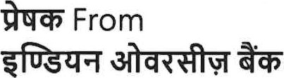  Indian Overseas Bank  HRMD - Pension Cell  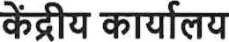Central Office |  | 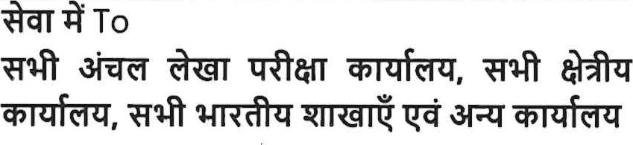  All Zonal Audit Offices, All Regional Offices,  All Indian Branches & Other Offices
83 / 2025-26 03.10,2025
Transient series (File:7(F)) Circular No. gof 2025-26 Date: 03.10.2025
INDIAN OVERSEAS BANK [EMPLOYEES'] PENSION REGULATIONS 1995
LIFE CERTIFICATES TO BE OBTAINED DURING OCTOBER/ NOVEMBER 2025
 | CERTIFICATES TO BE OBTAINED |  | ACTION TO BE TAKEN
 | l . Life Certificate from 10B Pensioners including Family Pensioners and Ex- Gratia relief pensioners. |  | All the 10B Pensioners/Family Pensioners can submit the Life certificates from 1 ^{st} November to 30th November 2025 (Pensioners in the age group of 80 years & above can submit life certificate from 01.10.2025)  For the current year, the Life Certificate are to be obtained from pensioners / family pensioners and the same to be updated in the system on or before 26.12.2025. If, life certificates are not updated in the system, pension will be stopped from December 2025 onwards.  The Life Certificate in physical mode can be submitted by the pensioners/family pensioners in any nearby 10B branch and need not visit the pension paying branch only.
 |  |  | Branch can update Life Certificate either through Jeevan Pramaan or through physical form for any retired staff, even if, they are not drawing pension
 | 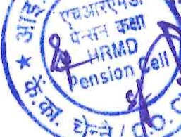
FROM 10B STAFF PENSIONERS/FAMILY PENSIONERS
Every year, Life Certificate along with other related certificates are to be obtained from the Pensioners / Family Pensioners in the month of October/November for continuing their pension. We advise the branches to obtain following certificates from 10B Pensioners / Family Pensioners / Ex-Gratia Pensioners during the month of October/November 2025.
from their branch, where they submit Life Certificate.
The life certificate obtained in physical mode by the branch, other than the pension drawing branch, the branch should forward the original Life Certificate to the respective pension drawing branch for keeping in their pensioner's file, after updatina the same online.
The Life certificate can also be updated either through mCHRlS app or through Jeevan Pramaan or through Video Based Life Certificate.
2. | Non-Remarriage/Non-marriage  Certificate from Widower/ Unmarried Daughters/Sons (up to the age of 25 years) who receive family pension. In respect of widow family pensioner, this certificate is obtained (as an undertaking) at the commencement of their family pension. | If remarried/married, payment of family pension will be discontinued from the date of remarriage/marriage and excess payment made to them is to be recovered and re-credited to us (Pension Cell 9040). If the certificate is not submitted, Branch to inform HRMD-Pension Cell,  CO for further course of action.
3. | Obtention of Life Certificate for Pensioners residing Abroad   | - An Authorised Official of the Embassy of India/High Commission of India/lndian Consulates may issue the life Certificate.  - In case the pensioner is unable to visit the Embassy/Consulate, he/she may submit requisite documents by post to the Embassy/Consulate, including Doctor's Certificate showing the pensioner's inability to present himself/herself in person. Embassy of India/High Commission/lndian Consulate may also assist pensioners/family pensioners in submission of the Life certificate.  - A Pensioner, not resident in India, in respect of whom a duly authorized agent produces a life certificate, signed by a Magistrate or a Notary or an officer of an Indian authorized Bank or Diplomatic Representative of India, is exempted from special appearance.
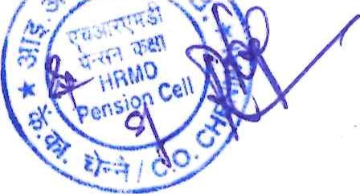
The certificates thus submitted should be filed in the respective pensioners' files for verification by the Inspecting Officials and not to be sent to Staff Pension Cell, Central Office. REPEAT NOTTO BE SENT TO STAFF PENSION CELL CENTRAL OFFICE.
Branches are instructed to complete the exercise on or before 26.12.2025. The Pension will be suspended from December 2025 onwards to those who have not submitted Life certificate and for whom the Branch has not updated in the system, if obtained in physical mode.
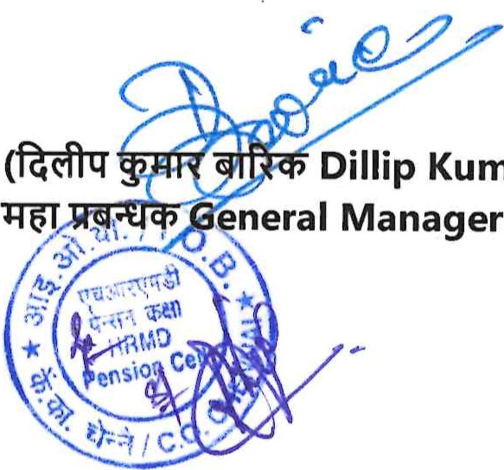
The physical Life Certificate format is also available in 10B ONLINE—>Staff Corner* Print your Retirees corner—>Staff Pension Life Certificate
Kumar
Barik)
For any clarifications, Branches can refer the following Circulars issued by our Centralised Pension Processing Centre, Central Office
- Transient Series (File:7-D) Circular No.47 of 2025-26 dated 30.09.2025
- Transient Series (File:7-D) Circular No.30 of 2018-19 dated 25.10.2018 regarding operational guidelines for obtaining Life Certificate through Jeevan Pramaan.
A copy of this circular is to be displayed in the notice board.

